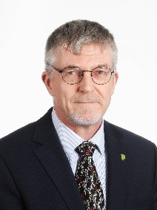
Mr. Kurt Kokko
Executive Director

Mr. Kokko was nominated Executive Director of the Safety Investigation Authority, Finland by the Government of Finland in December 2021. Mr. Kokko started his assignment in February 2022.
Starting his career in public service in 1984 as a training officer in a reconnaissance unit at the Coastal Ranger School and later transferred to the Finnish Border Guard as a chief of a guard station.
Mr. Kokko started as a research scientist in 1999 at a small drug development company Juvantia Pharma Ltd. His research concentrated overarchingly on neurological diseases such as Parkinson’s and Alzheimer's disease. He developed computational methods to speed up the drug discovery process for finding and developing potential small molecules.
In 2003, Mr. Kokko transferred to the Forensic Laboratory of the National Bureau of Investigation (NBI), where he first worked as an expert in the field of crimes of destruction and in technical investigations and later as a superior of various departments. He also helped to streamline the collaboration between the different units of the NBI and local police units – adding to the improvement of the overall situational awareness.
Mr. Kokko has also been the vice-chairman of Explosion Working Group in ENFSI (European Network of Forensic Science Institutes) and has co-authored technical guides of fire and explosion investigations.
Mr. Kokko joined SIAF as an external expert in 2005.
He has also been a professional diver specialized in demolitions underwater or on ground.
In 2016, Kurt started as a Head of Unit for market surveillance of professional products in the EU market at the Finnish Safety and Chemicals Agency.
Mr. Kokko has also been a member of several national advisory boards and the chairman of the EU Commission's AdCO working group on construction products.
Mr. Kokko holds a Master’s degree in Physical Chemistry, specializing in quantum chemistry and molecular modelling, from the University of Oulu. Mr. Kokko is a doctoral student at the National Defense University.
He is married and has two grown-up children.

